

|  |
| --- |
|  |
|  |
|  |
|  |
| **Yotpo**  **Salesforce Commerce Integration** |
|  |
| ***Yotpo Link Version 19.1.0*** |
|  |
|  |
|  |
|  |
|  |
|  |
|  |
|  |



Contents

[1. Summary 4](#_Toc6955816)

[2. Component Overview 5](#_Toc6955817)

[2.1 Functional Overview 5](#_Toc6955818)

[2.2 Use Cases 5](#_Toc6955819)

[2.2.1 Use Case # 1: Product Review Widget 5](#_Toc6955820)

[2.2.2 Use Case # 2: Star Rating Widget 5](#_Toc6955821)

[2.2.3 Use Case # 3: Automatic Review Requests (post purchase review request emails) 5](#_Toc6955822)

[2.2.4 Use Case # 4: Loyalty & Referrals 5](#_Toc6955823)

[2.3 Limitations, Constraints 6](#_Toc6955824)

[2.4 Compatibility 6](#_Toc6955825)

[2.5 Privacy, Payment 6](#_Toc6955826)

[3 Implementation Guide 7](#_Toc6955827)

[Prerequisites 7](#_Toc6955828)

[3.1 Setup 7](#_Toc6955829)

[3.2 Configuration 7](#_Toc6955830)

[3.2.1 Cartridge Registration 7](#_Toc6955831)

[3.2.1.1 Pipeline Version 7](#_Toc6955832)

[3.2.1.2 Controller Version 7](#_Toc6955833)

[3.2.1.3 SFRA Version 8](#_Toc6955834)

[3.2.1.4 Business Manager (Swell Loyalty Only) 8](#_Toc6955835)

[3.2.2 SiteGenesis Controller Cartridge Configuration 8](#_Toc6955836)

[3.2.3 Import Yotpo Metadata Services and Jobs Schedules: 9](#_Toc6955837)

[3.3 Job Details (Yotpo UGC Only) 9](#_Toc6955838)

[3.4 Services Details 9](#_Toc6955839)

[3.4.1 Authentication Service (Yotpo UGC Only) 9](#_Toc6955840)

[3.4.2 Export Purchase Service (Yotpo UGC Only) 10](#_Toc6955841)

[3.4.3 Import Review Service (Yotpo UGC Only) 10](#_Toc6955842)

[3.4.4 Export Order and Customer Service (Swell Loyalty Only) 10](#_Toc6955843)

[3.5 Custom Code Pipelines and Controllers 11](#_Toc6955844)

[3.5.1 Adding Yotpo JavaScript (Yotpo UGC + Swell Loyalty) 11](#_Toc6955845)

[3.5.2 Adding Yotpo Modules (Yotpo UGC Only) 11](#_Toc6955846)

[3.5.3 Adding Product Review Widget (Yotpo UGC Only) 11](#_Toc6955847)

[3.5.3.1 Pipelines Version: 11](#_Toc6955848)

[3.5.3.2 Controllers Version: 11](#_Toc6955849)

[3.5.4 Adding Star Rating Widget on Product (Yotpo UGC Only) 12](#_Toc6955850)

[3.5.5 Adding Star Rating Widget on Category (Yotpo UGC Only) 12](#_Toc6955851)

[3.5.6 Adding Purchase Conversion Tracking (Yotpo UGC Only) 13](#_Toc6955852)

[3.5.7 Adding Logged In Customer and Basket Tracking (Swell Loyalty Only) 13](#_Toc6955853)

[3.5.8 Adding Data Export Observers (Swell Loyalty Only) 13](#_Toc6955854)

[3.5.8.1 Order Observer 13](#_Toc6955855)

[3.5.8.2 Customer Observer 14](#_Toc6955856)

[3.6 Custom Code SFRA 15](#_Toc6955857)

[3.6.1 Adding Yotpo JavaScript (Yotpo UGC + Swell Loyalty) 15](#_Toc6955858)

[3.6.2 Adding Product Review Widget (Yotpo UGC Only) 16](#_Toc6955859)

[3.6.3 Adding Product Ratings Widget (Category and PDP) (Yotpo UGC Only) 16](#_Toc6955860)

[3.6.4 Adding Conversion Tracking Widget (Yotpo UGC Only) 16](#_Toc6955861)

[3.6.5 Adding Logged In Customer and Basket Tracking (Swell Loyalty Only) 16](#_Toc6955862)

[3.7 URL Mappings (Swell Loyalty Only) 16](#_Toc6955863)

[3.8 External Interfaces 17](#_Toc6955864)

[3.9 Testing 17](#_Toc6955865)

[4 Operations, Maintenance 18](#_Toc6955866)

[4.1 Data Storage 18](#_Toc6955867)

[4.2.1 Order Custom Attributes 18](#_Toc6955868)

[4.2.2 ProductLineItem Custom Attributes 18](#_Toc6955869)

[4.2.3 PriceAdjustment Custom Attributes 18](#_Toc6955870)

[4.2 Availability 19](#_Toc6955871)

[4.3 Support 19](#_Toc6955872)

[5 User Guide 20](#_Toc6955873)

[5.1 Roles, Responsibilities 20](#_Toc6955874)

[5.1.1 Permission Grant on Yotpo Module (Swell Loyalty Only) 20](#_Toc6955875)

[5.2 Business Manager 21](#_Toc6955876)

[5.2.1 Yotpo Site Preferences 21](#_Toc6955877)

[5.2.2 Login to Swell Loyalty (Swell Loyalty Only) 22](#_Toc6955878)

[5.2.3 Set up the yotpoConfiguration 23](#_Toc6955879)

[5.2.4 Set up the yotpoJobsConfiguration (Yotpo UGC Only) 24](#_Toc6955880)

[5.3 Storefront Functionality 24](#_Toc6955881)

[6 Known Issues 25](#_Toc6955882)

[7 Release History 26](#_Toc6955883)

# Summary

Yotpo’s suite of integrated solutions for user-generated content marketing, loyalty, and referrals helps commerce companies accelerate growth by enabling advocacy and maximizing customer lifetime value. With Yotpo, brands can effectively leverage social proof to increase trust and sales, cultivate loyal customer advocates, and make better business decisions based on customer feedback.

This document provides technical instructions for installing and using Yotpo Salesforce Commerce Link Cartridge, which enables you to integrate various Yotpo features within a Salesforce Commerce storefront.

Clients using the Yotpo Salesforce Commerce Link Cartridge can access the following features:

1. Product Review Widget
2. Star Rating Widget
3. Automatic Review Request Emails
4. Loyalty program (earning and redeeming points)
5. Referral program

In order to use the Salesforce Commerce Link Cartridge, customers must be in contract with Yotpo.

# Component Overview

## Functional Overview

Following is the list of features implemented in the Yotpo Link cartridge integration:

* Product Widgets
  + Product Review Widget.
  + Star Rating Widget.
* Automatic Review Request Emails
  + Order export
* Analytics.
  + Purchase conversion tracking.
* Swell Loyalty & Referrals
* For the storefront functionality to work properly, the following integration needs to be set up in Business Manager
  + Purchasers Feed Export Generation.

## Use Cases

### Use Case # 1: Product Review Widget



|  |  |
| --- | --- |
| **Use Case Scenarios** | **Result** |
| The merchant implements Product Review Widget in a page or pages in the store. | The user will be able to see Product Review Widget on those store pages. |

### Use Case # 2: Star Rating Widget

|  |  |
| --- | --- |
| **Use Case Scenarios** | **Result** |
| The merchant add Star Rating Widget on Product or Category Landing Page in the store. | The user will be able to see a Star Rating Widget on those store pages. |

### Use Case # 3: Automatic Review Requests (post purchase review request emails)

|  |  |
| --- | --- |
| **Use Case Scenarios** | **Result** |
| The merchant schedules the job that sends the order data to the Yotpo API. | The user’s customers will receive review request emails according to the Yotpo account configuration. |

### Use Case # 4: Loyalty & Referrals

|  |  |
| --- | --- |
| **Use Case Scenarios** | **Result** |
| The merchant configures the Order and Customer data export. | The users accumulate loyalty points and will receive discount coupons to be used in subsequent orders. |

## Limitations, Constraints

Use of the Yotpo LINK cartridge by itself does not grant nor enable use of Yotpo product offerings. Yotpo must separately come to a contractual agreement with the client in order for Yotpo to start collecting reviews on their behalf. Please contact Yotpo for details: <sales@yotpo.com>.

## Compatibility

The Yotpo LINK cartridge is compatible with Site Genesis version 13.6 or later

## Privacy, Payment

Masked Order Information and Aggregate Sales Information may be captured as part of purchase tracking implementation on the site.

No customer specific profile data or sensitive information will be stored related to Yotpo LINK cartridge.

The Yotpo LINK cartridge itself is available free of charge. See "Limitations, Constraints" section for details regarding potential costs involved with enabling Yotpo to start collecting reviews on your behalf.

In using the Yotpo LINK cartridge, you agree to be bound by our [Terms of Service](https://www.yotpo.com/terms-of-service/).

# Implementation Guide

## Prerequisites

A Yotpo representative must enable an account for the merchant, as part of which the merchant will be assigned a unique “app key” and “client secret key”.

## 3.1 Setup

The Yotpo LINK integration uses the following cartridges: **int\_yotpo, int\_yotpo\_sfra**, **int\_yotpo\_pipelines** and **bm\_yotpo**

## Configuration

### Cartridge Registration

Navigate to the following path "Sites **🡪** Manage Sites **🡪**  **<Merchant Site>** **🡪**  Settings"

Add the cartridge names to Cartridges path as shown in screenshot below:

#### Pipeline Version

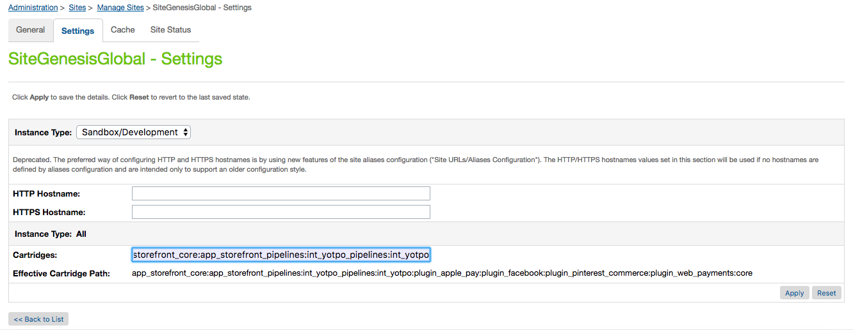

#### Controller Version

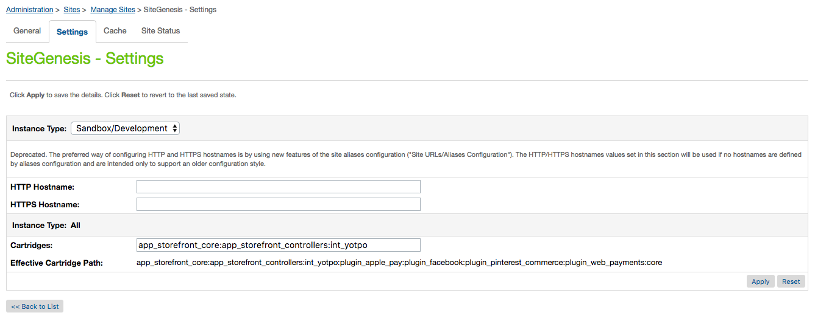

#### SFRA Version

**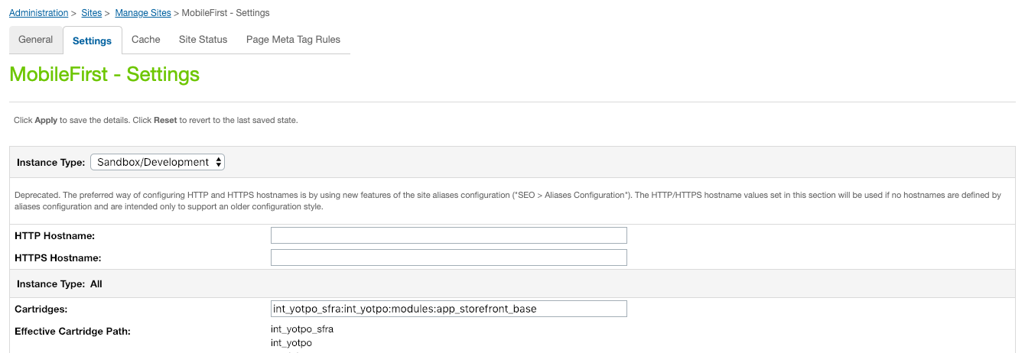**

#### Business Manager (Swell Loyalty Only)

The Yopto cartridge includes a custom interface in Business Manager to manage login to Swell Loyalty control panel. Only include **bm\_yotpo** cartridge if Swell Loyalty feature is enabled for your store.

Navigate to the following path "Sites **🡪** Manage Sites **🡪**  **Business Manager**" 🡪 Settings

Add the cartridge names to Cartridges path as shown in screenshot below:

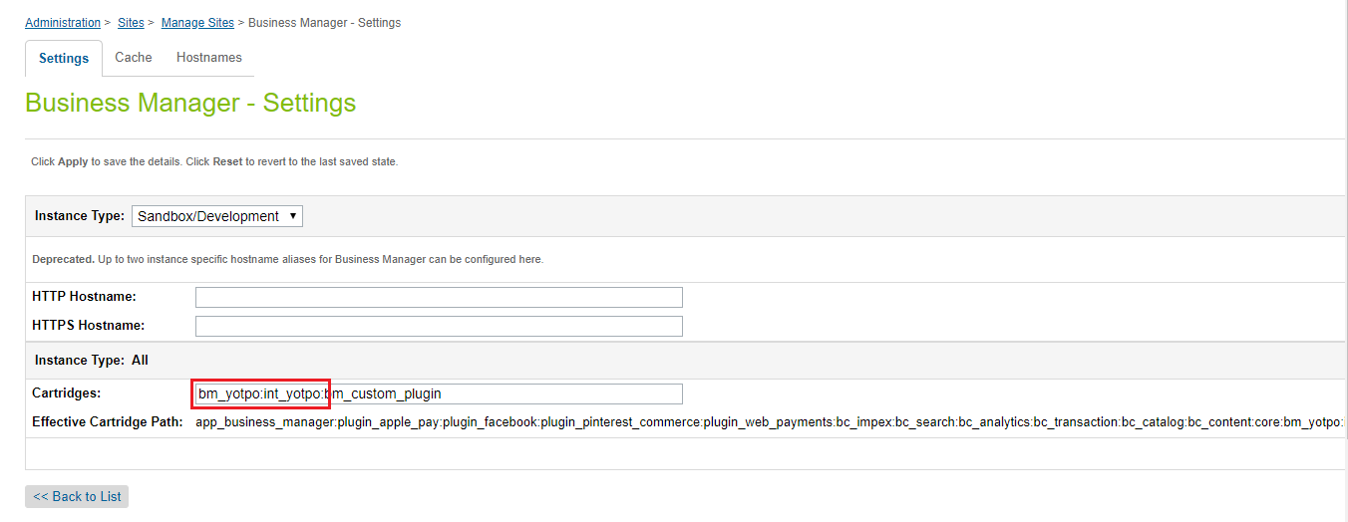

### SiteGenesis Controller Cartridge Configuration

The Yotpo cartridge relies on “guard” script from SiteGenesis Controller cartridge if the integration is being done with controller version. The default name that it uses is “app\_storefront\_controllers”.

If the controller cartridge name is different to default name then change; exports.SITEGENESIS\_CARTRIDGE\_NAME = "app\_storefront\_controllers";

In int\_yotpo/cartridge/scripts/yotpo/utils/Constants.js

### Import Yotpo Metadata Services and Jobs Schedules:

Get the metadata.zip file from Yotpo cartridge’s Metadata folder

* Navigate to Site Development **🡪** Site Import & Export.
* Select metadata.zip file and click on ‘Import’ and complete the import process through the interface.
* The Jobs, Services, Site Preferences, Custom Objects will be imported including Yotpo Configurations and Yotpo Jobs Configurations.
* The details on job schedules and services is described in section [3.3](#_Job_Details) and [3.4](#_Services_Details) respectively.
* The details on Yotpo Custom Preferences is described in [section 5.2.1](#_Yotpo_Site_Preferences). For further details on configuring custom objects see section [5.2.2](#_Set_up_the) and [5.2.3](#_Set_up_the_1).

## Job Details (Yotpo UGC Only)

|  |  |
| --- | --- |
| Name | Description |
| ExportOrders | This job is for Controller version SiteGenesis or SFRA. This job transfers the purchase feed to Yotpo. |
| ExportOrdersPipeline | This job is for Pipeline version SiteGenesis. This job transfers the purchase feed to Yotpo. |

**Note:** Only one is required, make sure to delete the one not required. Make sure to configure the correct site for each job schedule in Sites tab of each job schedule.

## Services Details

Navigate to Administration **🡪** Services.

After successfully importing services, following will be added:

|  |  |  |
| --- | --- | --- |
| Name | Profile | Credentials |
| int\_yotpo.https.post.auth.api | int\_yotpo.rest.api.profile | int\_yotpo.https.post.auth.api.cred |
| int\_yotpo.https.post.export.purchase.api | int\_yotpo.rest.api.profile | int\_yotpo.https.post.export.purchase.api.cred |
| int\_yotpo.http.post.import.reviews.api | int\_yotpo.rest.api.profile | int\_yotpo.http.post.import.reviews.api.cred |
| int\_yotpo.https.post.swell.api | int\_yotpo.rest.api.profile | int\_yotpo.https.post.swell.api.cred |

### Authentication Service (Yotpo UGC Only)

URL for authentication token API could be set in *int\_yotpo.https.post.auth.api.cred*

|  |
| --- |
|  |

**Note:** User and Password not required.

### Export Purchase Service (Yotpo UGC Only)

URL for Export Post API could be set in *int\_yotpo.https.post.export.purchase.api.cred*

|  |
| --- |
|  |

**Note:** User and Password not required. Also the **[appKey]** will be dynamically replaced in the code when making a service call.

### Import Review Service (Yotpo UGC Only)

URL for importing review could be set in *int\_yotpo.http.post.import.reviews.api.cred*

|  |
| --- |
|  |

**Note:** User and Password not required.

### Export Order and Customer Service (Swell Loyalty Only)

URL for exporting data to Swell could be set in *int\_yotpo.https.post.swell.api.cred*

|  |
| --- |
|  |

**Note:** User and Password not required.

## Custom Code Pipelines and Controllers

### Adding Yotpo JavaScript (Yotpo UGC + Swell Loyalty)

For widgets and conversion tracking to work, Yotpo's JavaScript must be included in storefront header file **i.e.** *htmlhead.isml*:

<isinclude template="include/yotpoheader" />

### Adding Yotpo Modules (Yotpo UGC Only)

In order to add widgets and tracking modules make sure the Yotpo module modules are added on the top of each template. Copy the below code snippet:

<isinclude template="util/yotpomodules.isml" />

### Adding Product Review Widget (Yotpo UGC Only)

Product Review Widget can be added to any product page in your store.

To add Product Review Widget include following Yotpo widget definition code snippet to the desired page **e.g.** at the end of product details block in *productcontent.isml*

#### Pipelines Version:

<isyotporeviewswidget product="${pdict.Product}"ispipeline="true" yotporeviewspage="1"isreview="true" />

#### Controllers Version:

<isyotporeviewswidget product="${pdict.Product}" yotporeviewspage="1" isreview="true"/>

yotporeviewspage is set to 1, but this can set to any arbitrary value to fetch specific review page. isreview should be set to true for loading reviews.

Yotpo reviews are fetched from Yotpo in real-time and response is rendered by *yotporeviewsresponse.isml.*  
The page is cached for 24 hours for performance concerns, which can be adjusted in the template.

|  |
| --- |
| C:\Users\Innovadel Tech\Desktop\yotpo screenshots\widget 1.png |

### Adding Star Rating Widget on Product (Yotpo UGC Only)

Star Rating Widget can be added to product page.

To add Star Rating Widget include following Yotpo widget definition code snippet to the desired page **e.g.** after product ID in *productcontent.isml*

<isyotpoproductbottomlinewidget product="${pdict.Product}"/>

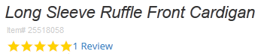

### Adding Star Rating Widget on Category (Yotpo UGC Only)

To add Star Rating Widget on Category/Search page, include following code snippet at top of the page **e.g** in *categoryproducthits.isml*

<isyotpocategorybottomlineheader />

And then add the following code snippet in the box below, to the desired page **e.g** in *producttile.isml* after or before the following code snippet.

<isif condition="${showrating && !Product.productSet}">

<isinclude template="product/components/reviewsmini"/>

</isif>

<isyotpocategorybottomlinewidget product="${pdict.product}"/>

|  |
| --- |
|  |

### Adding Purchase Conversion Tracking (Yotpo UGC Only)

Conversion Tracking should be added in “**confirmation page**” in your store.

In order to enable Conversion Tracking include following code snippet to the confirmation page **i.e.** at the end of *confirmation.isml*

<isyotpoconversiontracking order="${pdict.Order}" />

### Adding Logged In Customer and Basket Tracking (Swell Loyalty Only)

For logged in customer and his basket tracking for Yotpo Swell Loyalty, template must be included in storefront footer file **i.e.** *footer.isml* in SiteGenesis:

<isinclude template="include/yotpofooter" />

### Adding Data Export Observers (Swell Loyalty Only)

In order to export data for Swell Loyalty, add order observer and customer observer hooks in Site Genesis controllers. The details of controllers are described below.

#### Order Observer

The order observer hook should be added into **COSummary-Submit** controller after order creation with

following code snippet:

**var** order = placeOrderResult.Order;

**var** SwellExporter = require('int\_yotpo/cartridge/scripts/yotpo/swell/export/SwellExporter');

**var** result = SwellExporter.exportOrder({

orderNo: order.orderNo,

orderState: 'created'

});

“submit” function will look like this after adding the above code snippet:

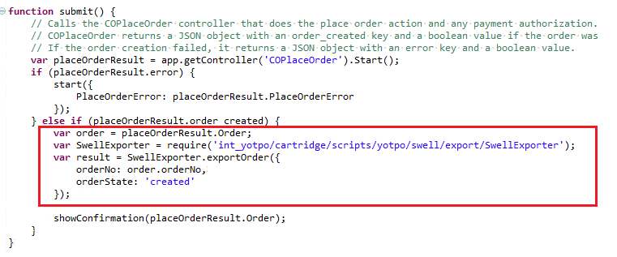

#### Customer Observer

The customer observer hook should be added into **Account-RegistrationForm** and **Account-EditForm** controllers with following code snippet:

**var** order = placeOrderResult.Order;

**var** SwellExporter = require('int\_yotpo/cartridge/scripts/yotpo/swell/export/SwellExporter');

**var** result = SwellExporter.exportCustomer({

customerNo: customer.profile.customerNo

});

After adding the above code snippet your controllers will look like this:

***Account-RegistrationForm***

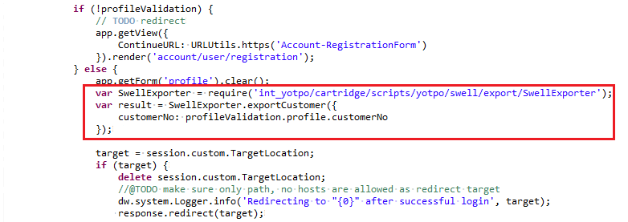

***Account-EditForm***

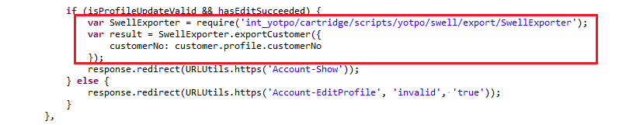

## Custom Code SFRA

The SFRA overridden templates resides in “**int\_yotpo\_sfra**”. SFRA architecture doesn’t allow extending template functionality therefore complete templates are overridden. It is highly recommended to copy the specific code only, if other cartridges have customised their functionality. The details of default overridden templates are described below.

### Adding Yotpo JavaScript (Yotpo UGC + Swell Loyalty)

For widgets and conversion tracking to work, Yotpo's dynamic JavaScript must be included in SFRA storefront header file **i.e.** *htmlhead.isml,*

<isinclude template="include/yotpoheader"/>

**See default overridden templates in the cartridge for reference:**

*“/int\_yotpo\_sfra/cartridge/templates/default/common/htmlHead.isml”*

### Adding Product Review Widget (Yotpo UGC Only)

Product reviews can be added to any product page in your store.

To add product reviews, override the desired template and include following code snippet in **e.g.** *descriptionAndDetails.isml*

<isinclude template="widget/yotporeviewswidget" />

**See default overridden templates in the cartridge for reference:** *“/int\_yotpo\_sfra/cartridge/templates/default/product/components/descriptionAndDetails.isml”*

### Adding Product Ratings Widget (Category and PDP) (Yotpo UGC Only)

Product ratings can be added to any product page/tile in your store.

To add product ratings override the desired template and include following code snippet in **e.g.** *productRating.isml* for Product Details Page and *ratings.isml* for Category/Search pages.

<isinclude template="widget/yotporatingswidget" />

**See default overridden templates in the cartridge for reference:**

*“/int\_yotpo\_sfra/cartridge/templates/default/product/components/productRating.isml”*

*“/int\_yotpo\_sfra/cartridge/templates/default/product/components/ratings.isml”*

### Adding Conversion Tracking Widget (Yotpo UGC Only)

Conversion Tracking should be added in “**confirmation page**” in your store.

In order to enable Conversion Tracking override any of order confirmation template **e.g.** *confirmation.isml* and include following code snippet;

<isinclude template="tracking/yotpoconversiontracking" />

**See default overridden templates in the cartridge for reference:** *“/int\_yotpo\_sfra/cartridge/templates/default/checkout/confirmation/confirmation.isml”*

### Adding Logged In Customer and Basket Tracking (Swell Loyalty Only)

For logged in customer and his basket tracking for Yotpo Swell Loyalty, template must be included in your storefront footer.

<isinclude template="include/yotpofooter" />

**See default overridden templates in the cartridge for reference:** *“/int\_yotpo\_sfra/cartridge*/*templates/default/components/footer/pageFooter.isml”*

## URL Mappings (Swell Loyalty Only)

Add following mappings URLs in Pipeline URLs

Navigate to "Merchant Tools **🡪** SEO **🡪** URL Rules 🡪 Pipeline URLs"

|  |  |
| --- | --- |
| Alias | Pipeline |
| swell/index/customer | SwellYotpo-GetCustomer |
| swell/index/customers | SwellYotpo-GetCustomers |
| swell/index/order | SwellYotpo-GetOrder |
| swell/index/orders | SwellYotpo-GetOrders |
| swell/index/order-count | SwellYotpo-GetOrderCountByState |
| swell/index/thirty-day-order-volume | SwellYotpo-GetOrderCountByVolume |
| swell/index/create-gift-certificate | SwellYotpo-CreateGiftCertificate |

***Note:*** *These endpoints are consumed by Yotpo server therefore it’s important to define these mappings since metadata import doesn’t set it up.*

## External Interfaces

There are no external interfaces

## Testing

To see a demo of product reviews and Star Rating visit the following pages:

<http://yotpo01-tech-prtnr-eu01-dw.demandware.net/s/SiteGenesis/en_US/womens/clothing/tops/25518058.html>

<http://yotpo01-tech-prtnr-eu01-dw.demandware.net/s/MobileFirst/black-single-pleat-athletic-fit-wool-suit/750518699578.html>

# Operations, Maintenance

## Data Storage

### Order Custom Attributes

|  |  |  |
| --- | --- | --- |
| **Attribute Definitions** | | |
| **ID** | **Name** | **Type** |
| userAgent | User Agent | String |
| userIPAddress | User IP Address | String |
| **Attribute Grouping** | | |
| **ID** | **Name** | |
| YotpoAttributes | Yotpo Attributes | |

### ProductLineItem Custom Attributes

|  |  |  |
| --- | --- | --- |
| **Attribute Definitions** | | |
| **ID** | **Name** | **Type** |
| swellPointsUsed | Swell Points Used | Integer |
| swellRedemptionId | Swell Redemption Id | String |

### PriceAdjustment Custom Attributes

|  |  |  |
| --- | --- | --- |
| **Attribute Definitions** | | |
| **ID** | **Name** | **Type** |
| swellPointsUsed | Swell Points Used | Integer |
| swellRedemptionId | Swell Redemption Id | String |

## Availability

Yotpo services are based on a high-availability infrastructure and have 99.9% uptime. If Yotpo endpoints go down and your pages are unable to get reviews and from our servers, the Yotpo reviews and Star Rating will simply not show, it won’t degrade or break your page in any way.

## Support

Contact [Yotpo Support](https://my.yotpo.com/contact_support) regarding this LINK cartridge.

# User Guide

## Roles, Responsibilities

Yotpo Export Orders job should be scheduled to run at least once daily.

Make sure **enablePurchaseFeed, enableReviews** and **enableBottomLine** is enabled in

“Merchant Tools **🡪** Custom Objects **🡪** Custom Objects Editor **🡪** Yotpo Configurations for a specific locale to make ratings, reviews or conversation tracking work.

### Permission Grant on Yotpo Module (Swell Loyalty Only)

The permission to access the Yotpo module needs to be granted to a specific role. Navigate to following path:

Administration 🡪 Organization 🡪 Roles & Permissions

Select the specific role needs to be granted e.g. Administrator and open the Business Manager Module tab as shown below in the screenshot;

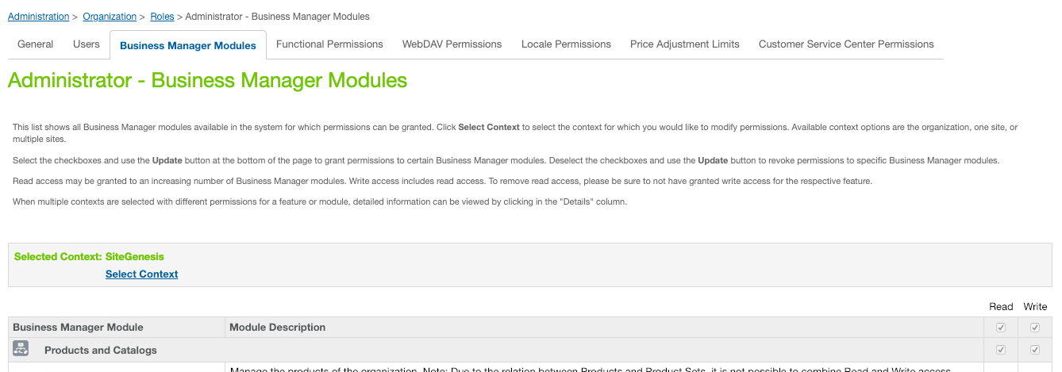

Select the specific site in Select Context and click Apply. Scroll down to Yotpo Swell Login module and select the checkbox to provide access to user role. Please see below in the screenshot for reference;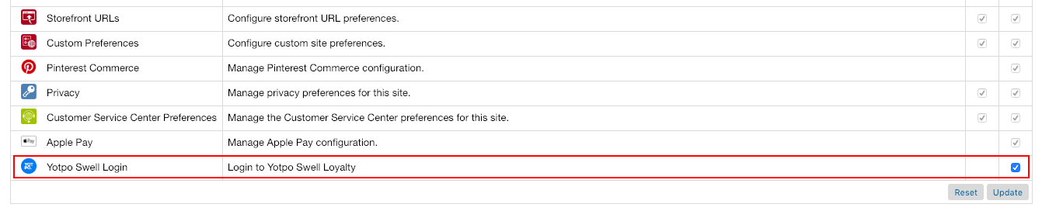

## Business Manager

### Yotpo Site Preferences

The Yotpo LINK cartridge consists of the following configuration properties in

“Site **🡪** Site Preferences **🡪** Custom Preferences **🡪** Yotpo Configurations”:

|  |
| --- |
|  |

|  |  |  |  |  |  |  |  |  |  |  |  |  |  |  |  |  |  |  |  |  |  |  |  |  |
| --- | --- | --- | --- | --- | --- | --- | --- | --- | --- | --- | --- | --- | --- | --- | --- | --- | --- | --- | --- | --- | --- | --- | --- | --- |
| |  |  | | --- | --- | | Custom Attribute Name | Function | | Yotpo Cartridge Enabled | This attribute is used to enable or disable the yotpo cartridge | | Swell Loyalty Enabled | This attribute is used to enable or disable Swell Loyalty feature | | Yotpo Static Content URL | This is the base URL to load static content from Yotpo | | Yotpo Conversion Tracking Pixel URL | This is the URL of the conversion tracking pixel. | | Import Reviews Realtime | This preference is used to decide whether to import reviews real-time or not. | | Product Information From Master | This site preference is used to make production information configurable whether the information will be exported from master or from variants. | | Export Group Id In Order | This site preference is used to make the logic configurable that whether the master product if will be exported in JSON or not. | | Yotpo Orders Batch Size | This attribute contains batch size for number of orders that should be processed at one time, while exporting purchase feed. | | Yotpo Swell Static Content URL | This site preference is used to set URL to load static content for Yotpo Swell JavaScript. | | Yotpo Info Log Enabled | The flag controls the info log level in whole Yotpo cartridge. By default, the info log will be disabled, therefore to enable the checkbox should be checked. | | Yotpo Debug Log Enabled | The flag controls the debug log level in whole Yotpo cartridge. By default, the debug log will be disabled, therefore to enable the checkbox should be checked. | |

**Note:** The default values are already set; therefore, you don’t need to change anything unless needed.

### Login to Swell Loyalty (Swell Loyalty Only)

You can login to Yotpo’s Swell Loyalty dashboard using business manager module.

Navigate to "Merchant Tools **🡪** Site Preference **🡪** Yotpo Swell Login"

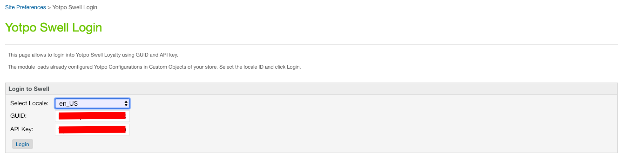

Select specific locale which are configured in Yotpo Configurations (custom object), the GUID and API key will be automatically populated. Then click login, a new window will pop up which will log you in automatically to Swell Loyalty dashboard.

### Set up the yotpoConfiguration

Navigate to "Merchant Tools **🡪** Custom Objects **🡪** Custom Object Editor"

Select "yotpoConfigurations" and press New as shown in the screenshot below:

|  |
| --- |
| C:\Users\Innovadel Tech\Desktop\yotpo screenshots\yotpo_conf_object.png |

|  |  |
| --- | --- |
| Custom Attribute Name | Function |
| localeID | The Locale ID which represents a specific account on Yotpo. This locale ID should always be entered from the selected Locales configured at Administration > Global Preferences > Locales |
| App Key | An App key which can be used for a specific account on Yotpo |
| Client Secret Key | A Client Secret Key which contains information for a specific account on Yotpo |
| Enable BottomLine | A flag used to indicate whether the star ratings are enabled or disabled for the specific Locale. |
| Enable Purchase Feed | A flag used to indicate whether the purchase feed is enabled or disabled for the specific Locale. |
| Enable Reviews | A flag used to enable or disable the reviews for the specific Locale. |
| utoken Authentication Code | A token which retrieved from Yotpo Authentication call response. It remains valid for some hours before it expires. If once expires it is updated by the Yotpo authentication process automatically. |
| Swell Loyalty GUID | A GUID key which is associated with a specific account on Yotpo’s Swell Loyalty. |
| Swell Loyalty API Key | A API key which is associated with a specific account on Yotpo’s Swell Loyalty. |

### Set up the yotpoJobsConfiguration (Yotpo UGC Only)

Select "yotpoJobsConfigurations" and press New as shown in the screenshot below:

Navigate to "Merchant Tools **🡪** Custom Objects **🡪** Custom Object Editor"

|  |
| --- |
| C:\Users\Innovadel Tech\Desktop\yotpo screenshots\yotpo_conf_attributes.png  C:\Users\Innovadel Tech\Desktop\yotpo screenshots\yotpo_job_confg_attributes.png |

|  |  |
| --- | --- |
| **Custom Attribute Name** | **Function** |
| **Order Feed Job Last Execution Date Time** | This attribute used to store the order feed job last execution date time. This is automatically updated by Export Orders process, however initially it should be set to some specific date in the past. |
| **Id** | The Id of the custom object, which should always be “1”. |

## Storefront Functionality

N/A

# Known Issues

N/A

# Release History

|  |  |  |
| --- | --- | --- |
| **Version** | **Date** | **Changes** |
| **15.1.0** | 26/07/2015 | Initial Release. |
| **15.1.1** | 10/11/2015 | Added new site preference details in the document. |
| **16.1.0** | 06/6/2016 | Bug fixes and services framework implementation. |
| **17.1.0** | 24/06/17 | Migration to controller framework. Removed reviews and ratings static load feature. Added real time reviews load for product page. |
| **18.1.0** | 11/02/18 | Added SFRA compatibility for Yotpo cartridge. Replaced deprecated ServiceRegistry with LocalServiceRegistry |
| **19.1.0** | 05/01/19 | Incorporated Yotpo’s Swell Loyalty functionality in the cartridge for Controller and RFA version sites. |

